* Disk Partition

**Disk partition** is the method of dividing hard drive into multiple logical storage

**ATA**

defines how data is transferred between a computer's motherboard and storage devices, such as

*hard disk drives

*solid-state drives

[SATA] Serial Advanced Technology Attachment

->data is transferred one by one

[PATA] Parallel Advanced Technology Attachment

->multiple data bits at the same time

Virtual

**Types of partition:**

MBR -->master boot record [max partition->4=3 primary,1 extended]

GPT -->guid partition table [max partition->128]

**Important commands:**

lsblk -->listing blocks,shows system partition

fdisk -l -->disk detiail

df -hT -->check file type with mount point

partprobe --> save changes to kernel without reboot

**Add new disk**

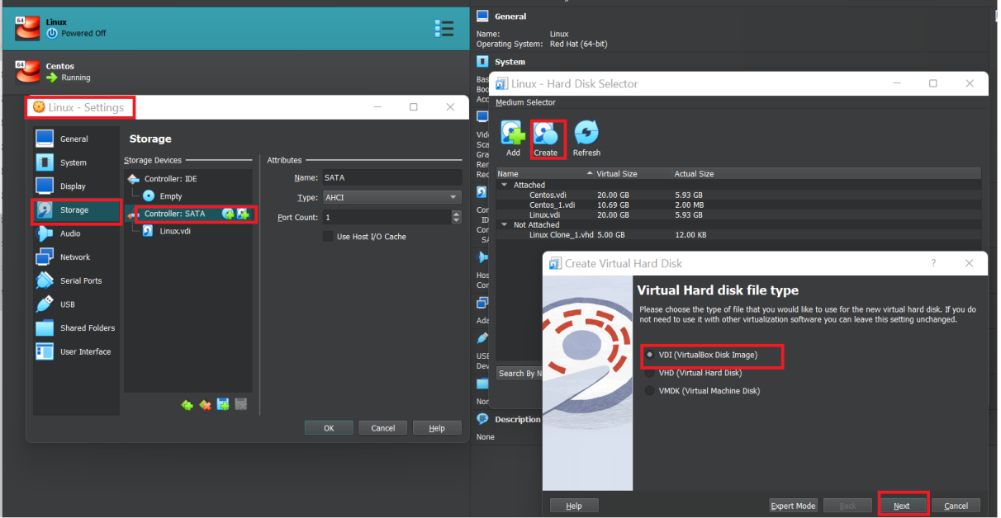

**Click on setting ->Storage->controller SATA**

**Click on + sign [ new page will pop up ]**

**Click on create -> select virtual disk image ->next**

**Choose disk -> attach to virtual Machine**

Start the machine

**#lsblk** ->this command will list all the drives in your system

->you can see sdb disk is added to system

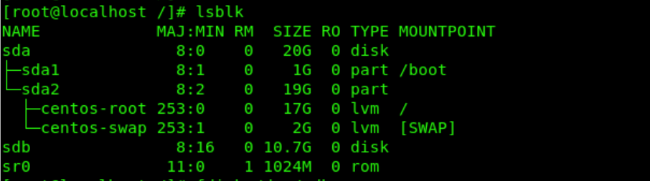

**#fdisk /dev/sdb -> this command will initiate new partition**

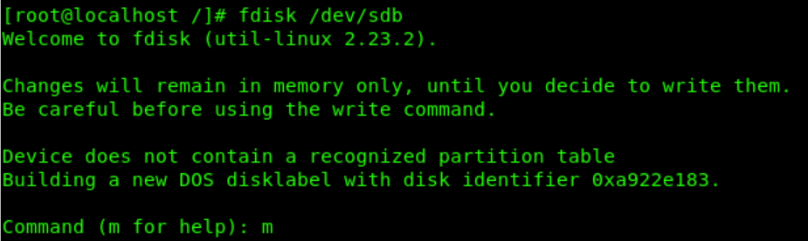

Press m for help (it will show all the options related to disk partition)

n to create new partition

p print partition table

w save the changes

d delete partition

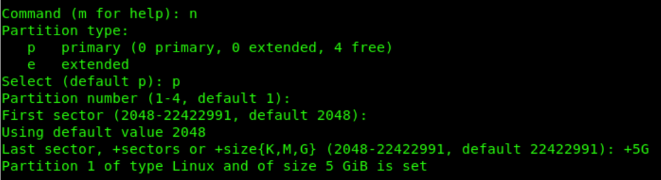

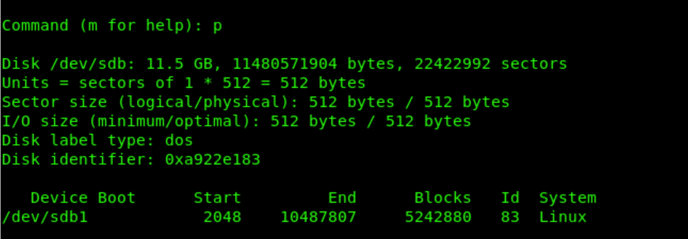



Select partition type

Press p for primary

Partition number ->just press enter

First sector ->just press enter

Last sector +size{K,M,G} -> +5G

Press m for help

Press p to print partition table

Press w to save

* Use **partprobe** command to save changes in kernel [it does not required reboot]
* Now  **attached a file system** to a partion using mkfs command



**Mount the partition** to dir [you can create new dir or use existing one]

**#df -hT** -->list partition along with file-system and mount point

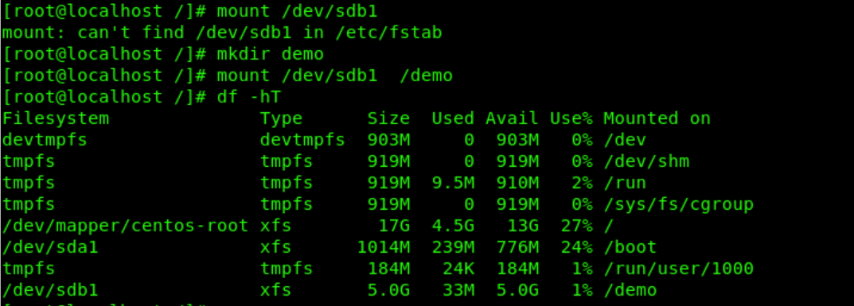

**Mount drive permanently**





